Machine Learning Binary classifier home work

Due: Start of class Feb

**DATA SET 1**

|  |  |
| --- | --- |
| Value | Type |
| 1 | Red |
| 1 | Red |
| 2 | Red |
| 4 | Blue |
| 5 | Red |
| 7 | Blue |
| 10 | Blue |
| 14 | Blue |
| 15 | Blue |
| 16 | Blue |

1. Consider a binary classifier with one parameter. Prediction is Blue if the value is greater than 3.
   1. Create the confusion matrix for data set 1.

|  |  |
| --- | --- |
| 6 | 0 |
| 1 | 3 |

* 1. Compute accuracy, precision, sensitivity, and specificity.

9/10

1

6/7

1

* 1. Compute the F and G score

.923

.9258

1. Consider a binary classifier with one parameter. Prediction is Blue if the value is greater than 6.
   1. Create the confusion matrix for data set 1.

|  |  |
| --- | --- |
| 5 | 0 |
| 4 | 1 |

* 1. Compute accuracy, precision, sensitivity, and specificity.

3/5

1

5/9

1

* 1. Compute the F and G score

.714

.745

1. Which of the previous classifiers would you prefer for the data set 1? Explain your choice.
2. The sigmoid function is defined as



It has an S shape and limits to 0 and 1.

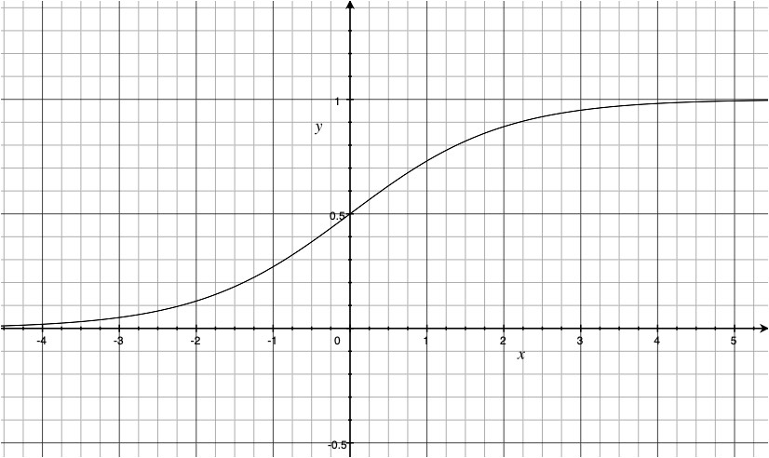

This makes it suitable to use as a classifier with two parameters that returns a probability. W specifies the steepness of the transition. (Larger W is steeper). K specifies the middle of sigmoid. (Where the probability is 0.5)



a) Fill in the following table using . If p is > ½ predict Blue

|  |  |  |  |  |
| --- | --- | --- | --- | --- |
| x | Type | probability | prediction | Log-Loss |
| 1 | Red |  |  |  |
| 1 | Red |  |  |  |
| 2 | Red |  |  |  |
| 4 | Blue |  |  |  |
| 5 | Red |  |  |  |
| 7 | Blue |  |  |  |
| 10 | Blue |  |  |  |
| 14 | Blue |  |  |  |
| 15 | Blue |  |  |  |
| 16 | Blue |  |  |  |

b) Compute the average log-loss

c) Fill in the following table using . If p is > ½ predict Blue

|  |  |  |  |  |
| --- | --- | --- | --- | --- |
| x | Type | probability | prediction | Log-Loss |
| 1 | Red |  |  |  |
| 1 | Red |  |  |  |
| 2 | Red |  |  |  |
| 4 | Blue |  |  |  |
| 5 | Red |  |  |  |
| 7 | Blue |  |  |  |
| 10 | Blue |  |  |  |
| 14 | Blue |  |  |  |
| 15 | Blue |  |  |  |
| 16 | Blue |  |  |  |

d) Compute the average log-loss

e) Based on the average log-loss, which classifier do you prefer?

**DATA SET 2**

|  |  |
| --- | --- |
| Value | Type |
| 1 | Red |
| 1 | Red |
| 2 | Red |
| 3 | Blue |
| 4 | Red |
| 5 | Blue |
| 7 | Blue |
| 10 | Blue |
| 14 | Red |
| 15 | Blue |
| 16 | Red |
| 19 | Red |
| 20 | Red |

1. Consider a binary classifier with two parameters. Prediction is Red if the value is less than 3 or greater than 15. Blue, otherwise.
   1. Create the confusion matrix for data set 2.
   2. Compute accuracy, precision, sensitivity, and specificity.
   3. Compute the F and G score